CSP Activity 1.1.4 - Spinning with Spirographs

Kyle Huang - Period 5 CSP

STEP 6:

| # get two numbers from user  a = int(input("Please enter number a. "))  b = int(input("Please enter number b. "))  # loop while the numbers are not divisible (the remainder is 0)  while (a % b > 0):  # inform user of result  print("a and b are not divisible. Please try again.")  # gather user input again  a = int(input("Please enter number a. "))  b = int(input("Please enter number b. "))  # inform user of result  print("a is divisible by b.") |
| --- |

STEP 13:

| import turtle as trtl  painter = trtl.Turtle()  painter.shape("circle")  painter.hideturtle()  painter.penup()  x = -200  while (x < 200):  x = x + 50  y = 200  painter.goto(x,y)  painter.color("red")  painter.stamp()  while (y > 0):  y = y - 50  painter.goto(x,y)  painter.color("blue")  painter.stamp()  wn = trtl.Screen()  wn.mainloop() |
| --- |

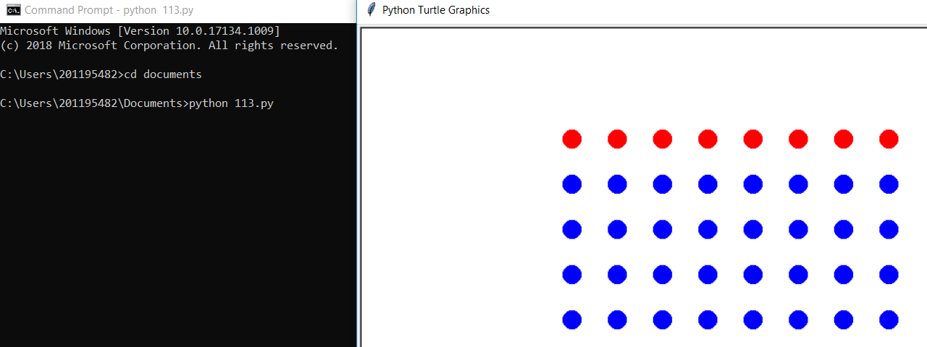

STEP 14:

| import turtle as trtl  painter = trtl.Turtle()  painter.shape("circle")  painter.hideturtle()  painter.penup()  painter.speed(0)  y = 200  while (y > -200):  x = -200  y -= 50  painter.goto(x,y)  painter.color("purple")  painter.stamp()  while (x < 150):  x = x + 50  painter.goto(x,y)  painter.color("orange")  painter.stamp()  wn = trtl.Screen()  wn.mainloop() |
| --- |

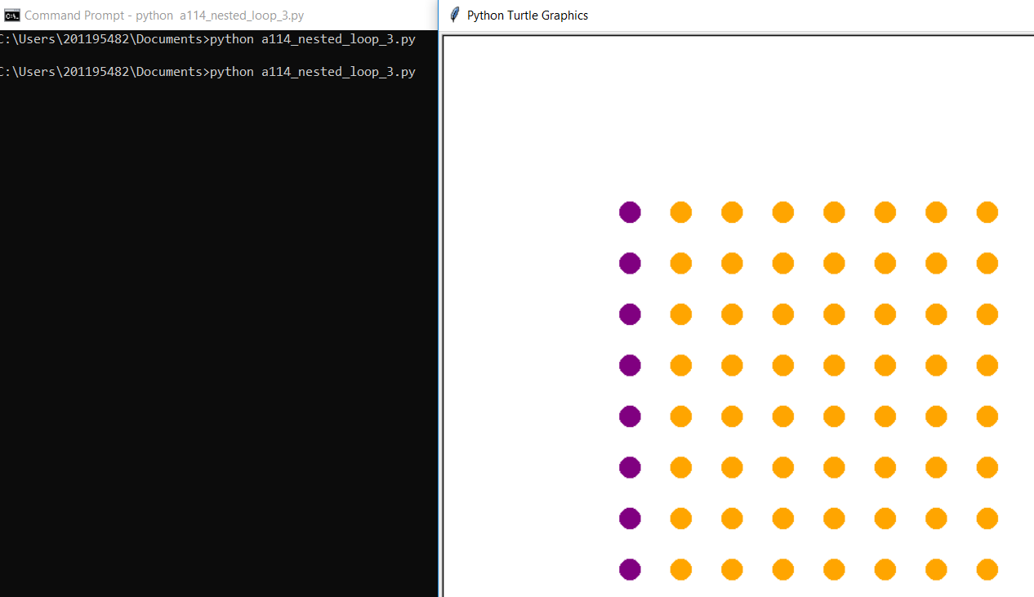

STEP 19

| import turtle as trtl  painter = trtl.Turtle()  painter.penup()  painter.goto(-200, 0)  painter.pendown()  x = -200  y = 0  move_x = 1  move_y = 1  while True:  while (x < 100):  while (y < 100):  x = x + move_x  y = y + move_y  painter.goto(x,y)  move_y = -1    while (y > 0):  x = x + move_x  y = y + move_y  painter.goto(x,y)  move_y = 1  while (x > -100):    while (y > -100):  x = x - move_x  y = y - move_y  painter.goto(x,y)  move_y = -1    while (y < 0):  x = x - move_x  y = y - move_y  painter.goto(x,y)  move_y = 1  wn = trtl.Screen()  wn.mainloop() |
| --- |

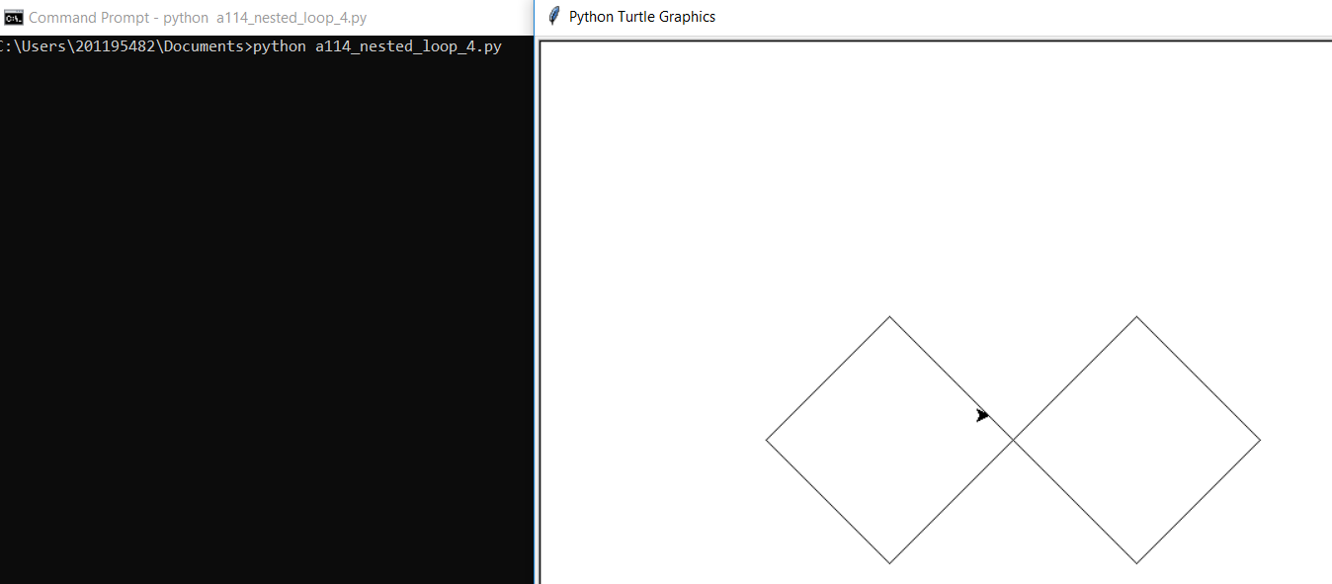

Stop 22:

